PROJECT DEVELOPMENT DELIVERY OF SPRINT-2

Proposed architecture for smart track monitoring system.
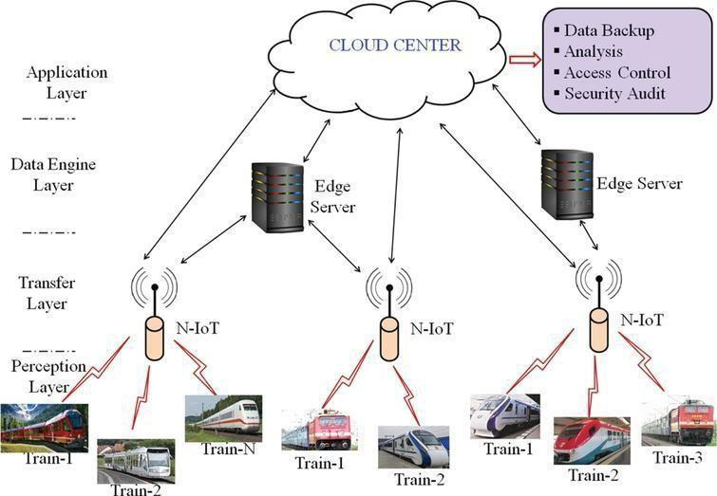

Structural health monitoring of railway tracks using IOT-based multi robot system:
